**WINAIM** - Screening Assignment - 2023 & 2024 YOP

**Programming Assessment**

**Exercise 2:** Human Resources Management System **(HRMS)**

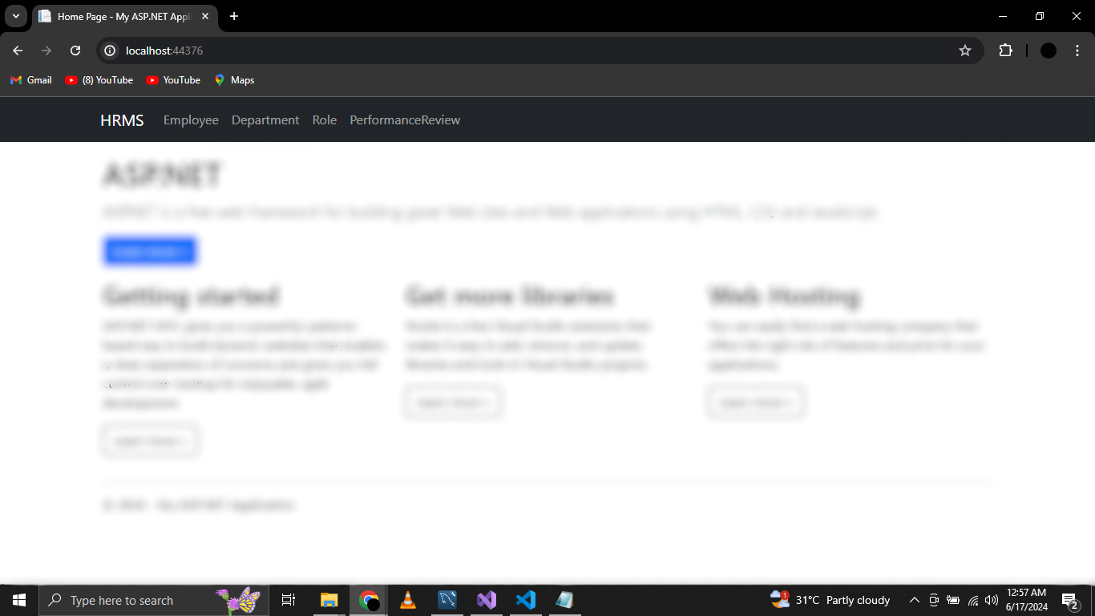

**Add, edit, delete, and view employee records.**

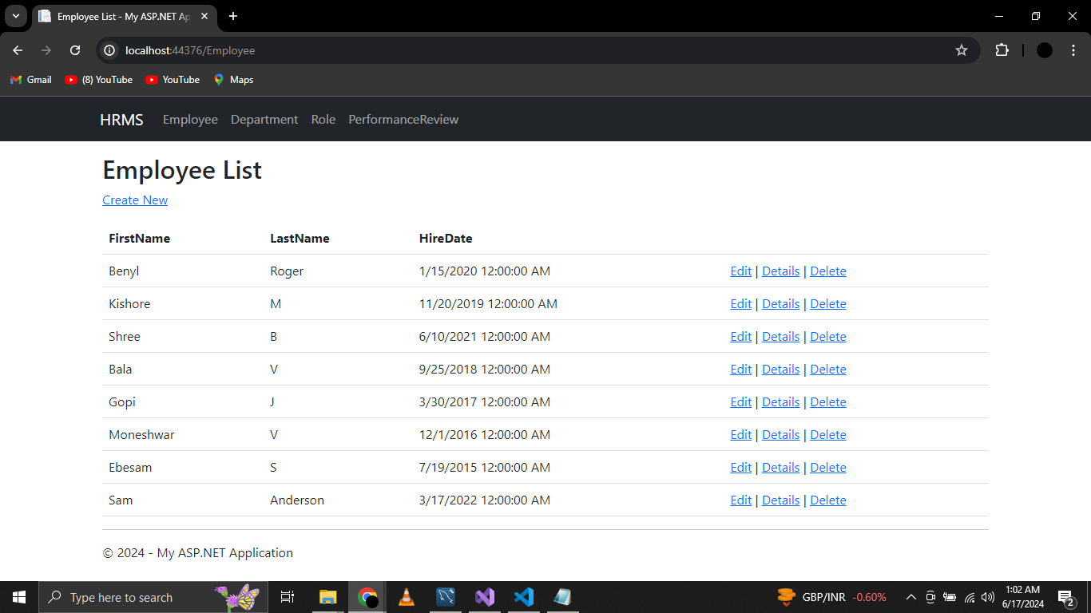

**Assign employees to departments and roles.**

**Create Employee**

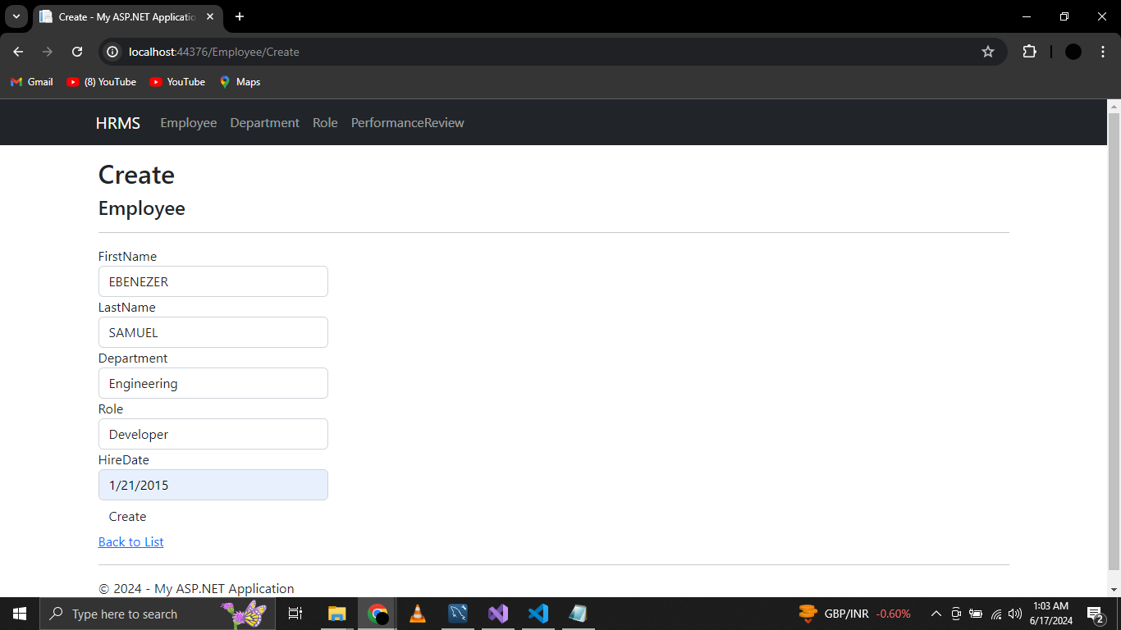

**Edit Employee**

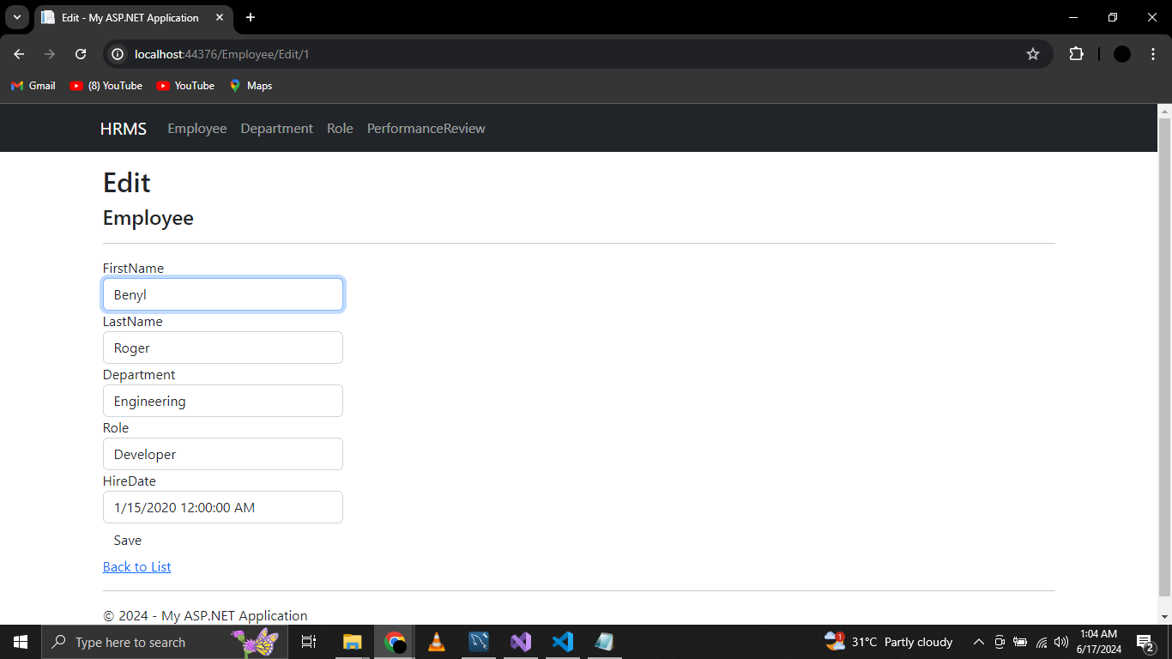

**Employee Details**

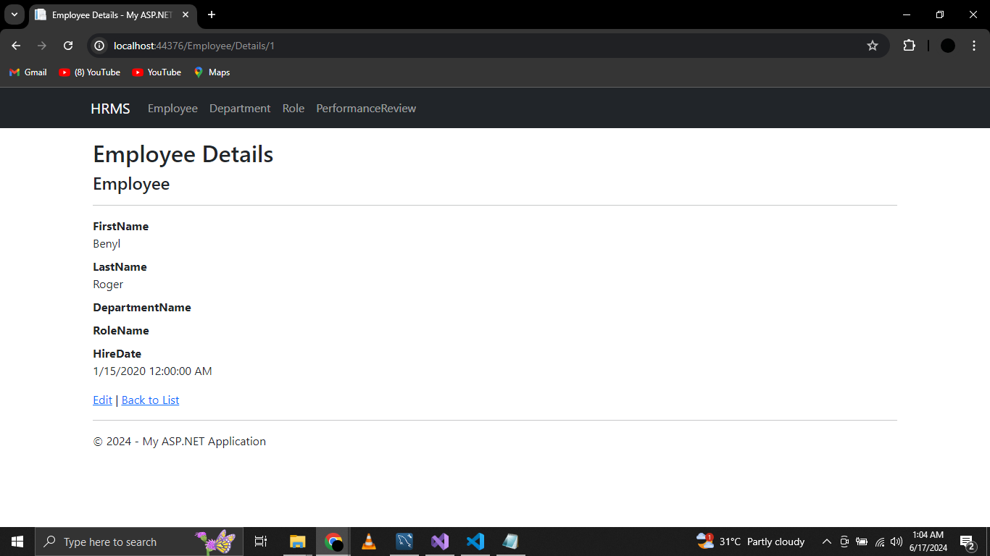

**Delete Employee**

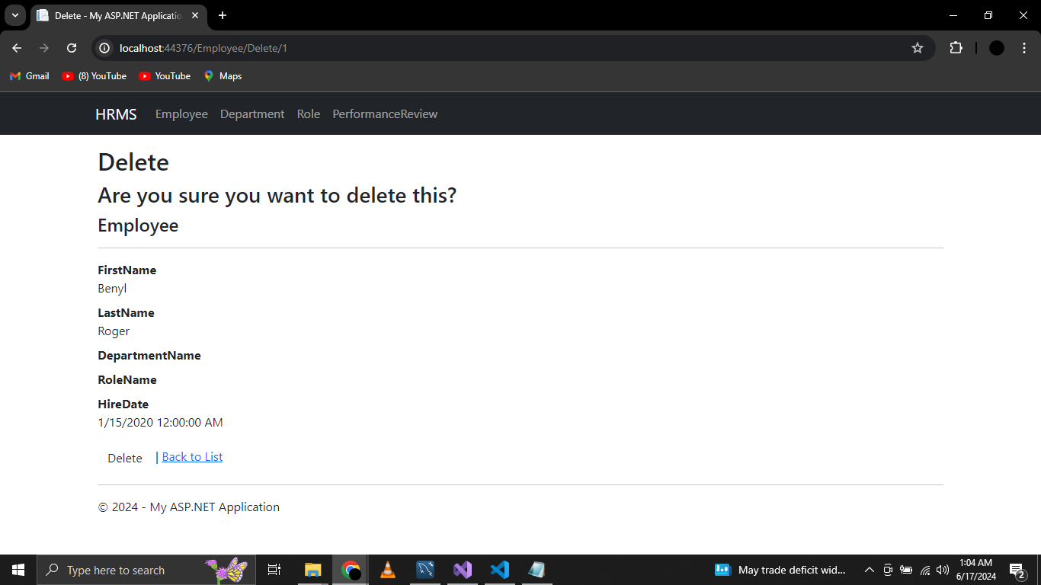

**Department List**

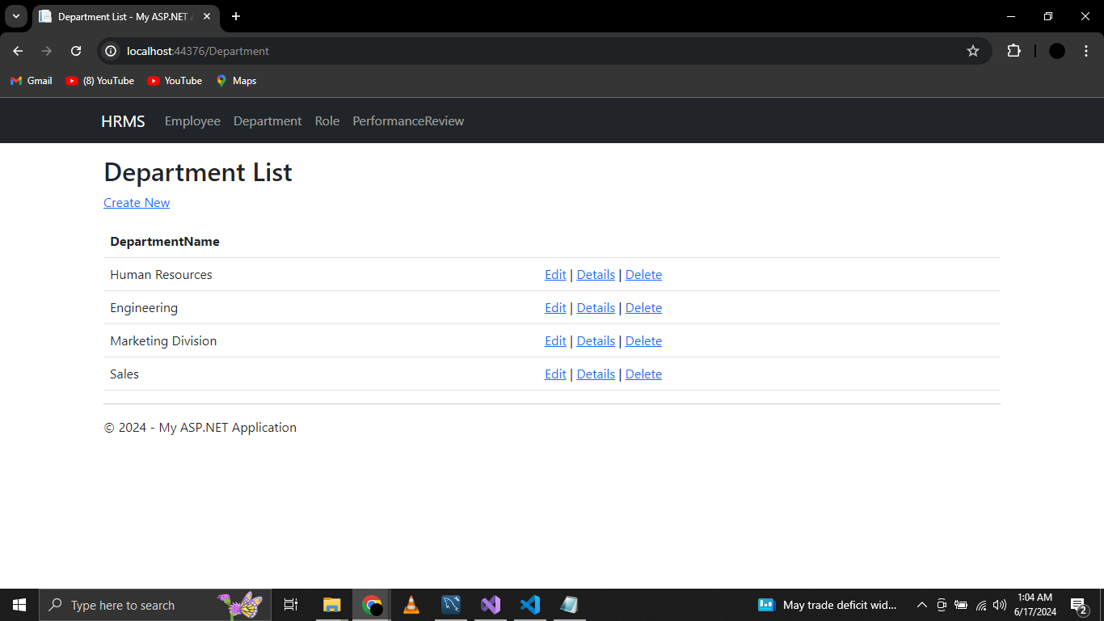

**Create Department**

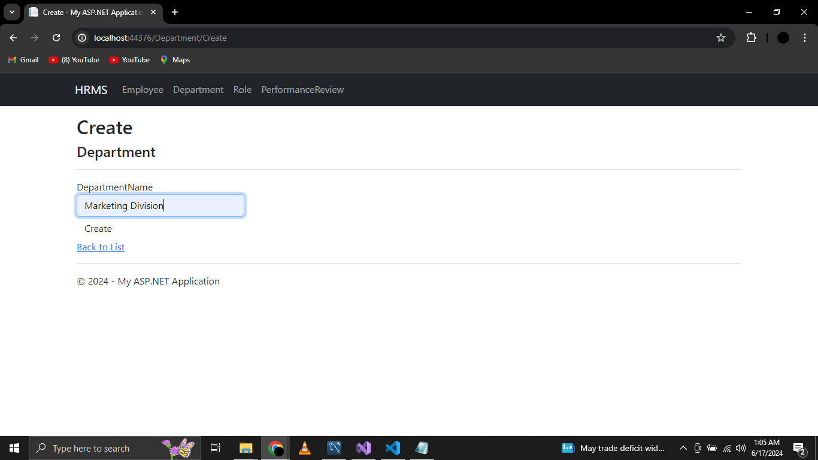

**Edit Department**

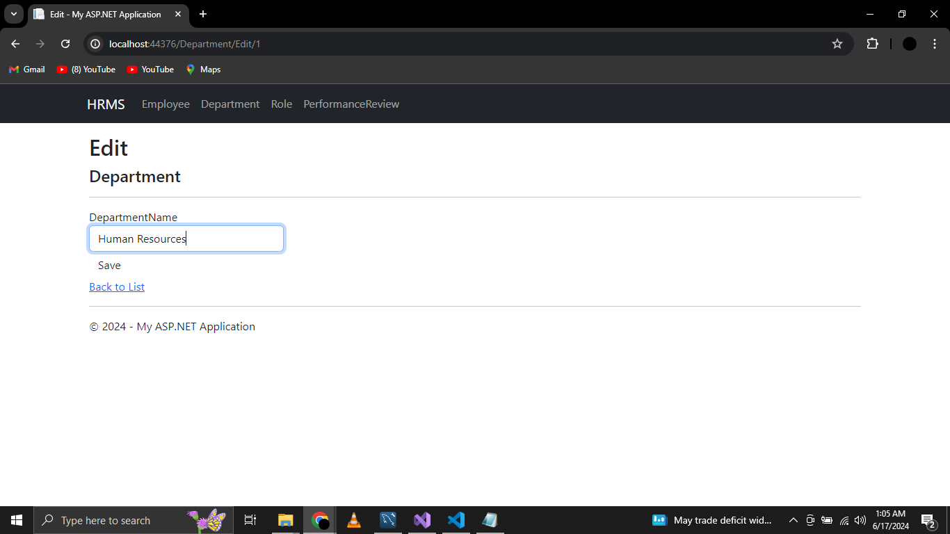

**Delete Department**

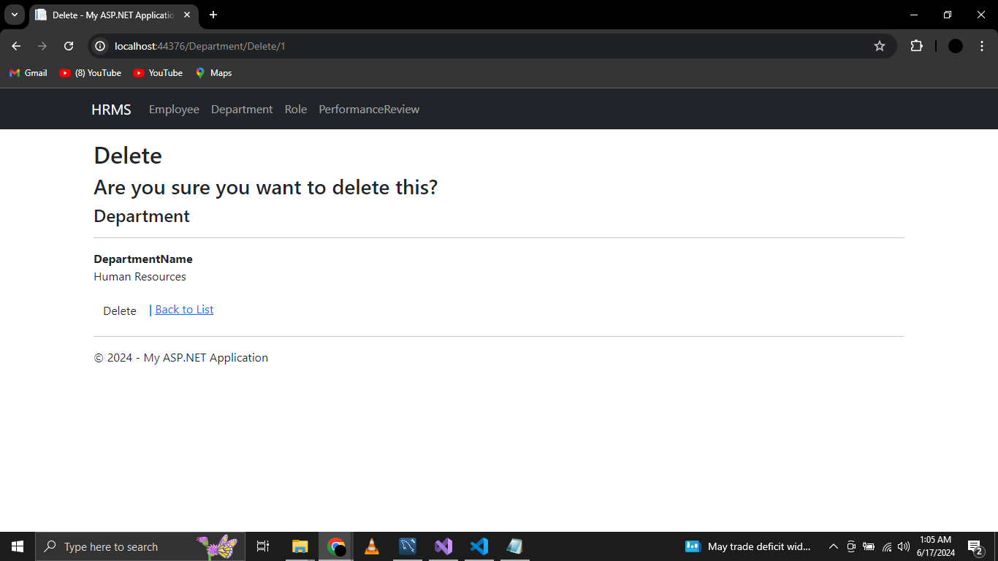

**List of Roles**

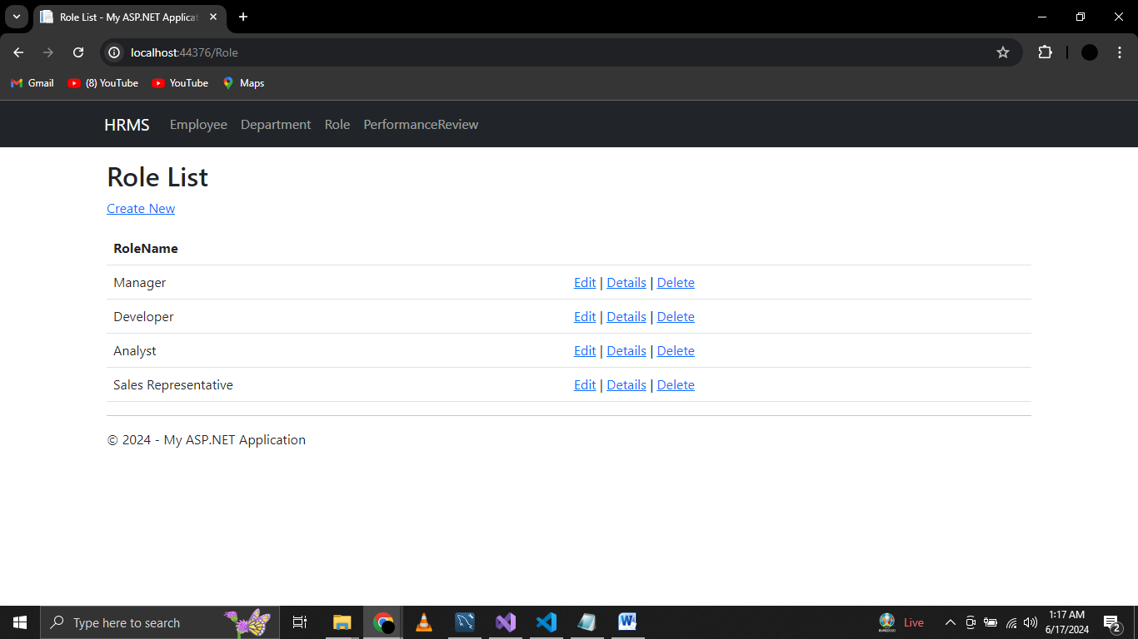

**Role Creation**

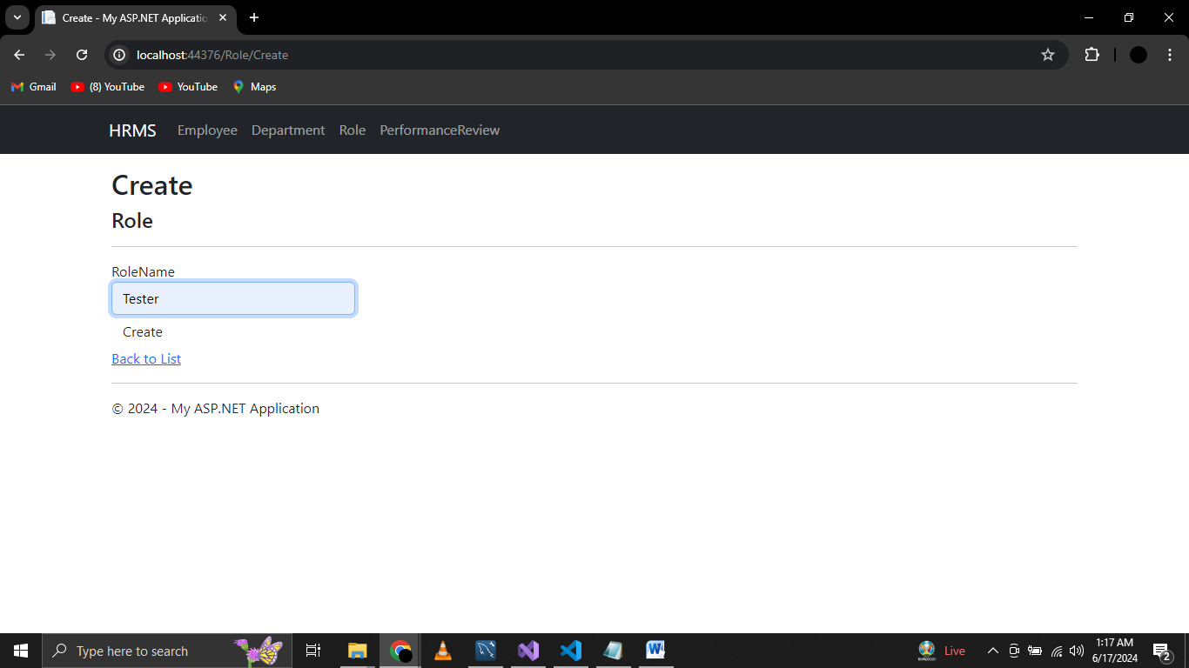

**Edit Role**

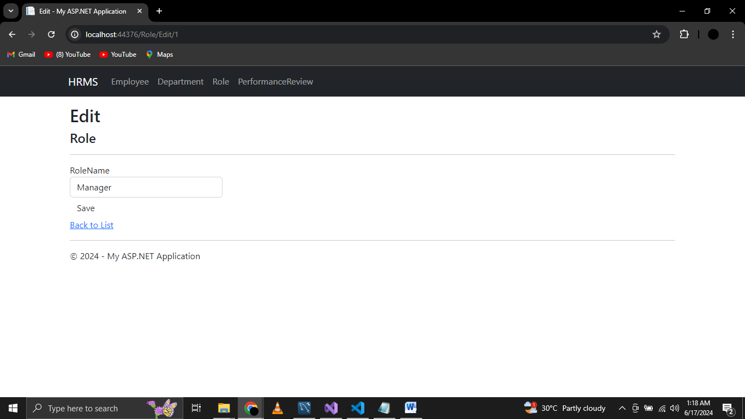

**Role Details**

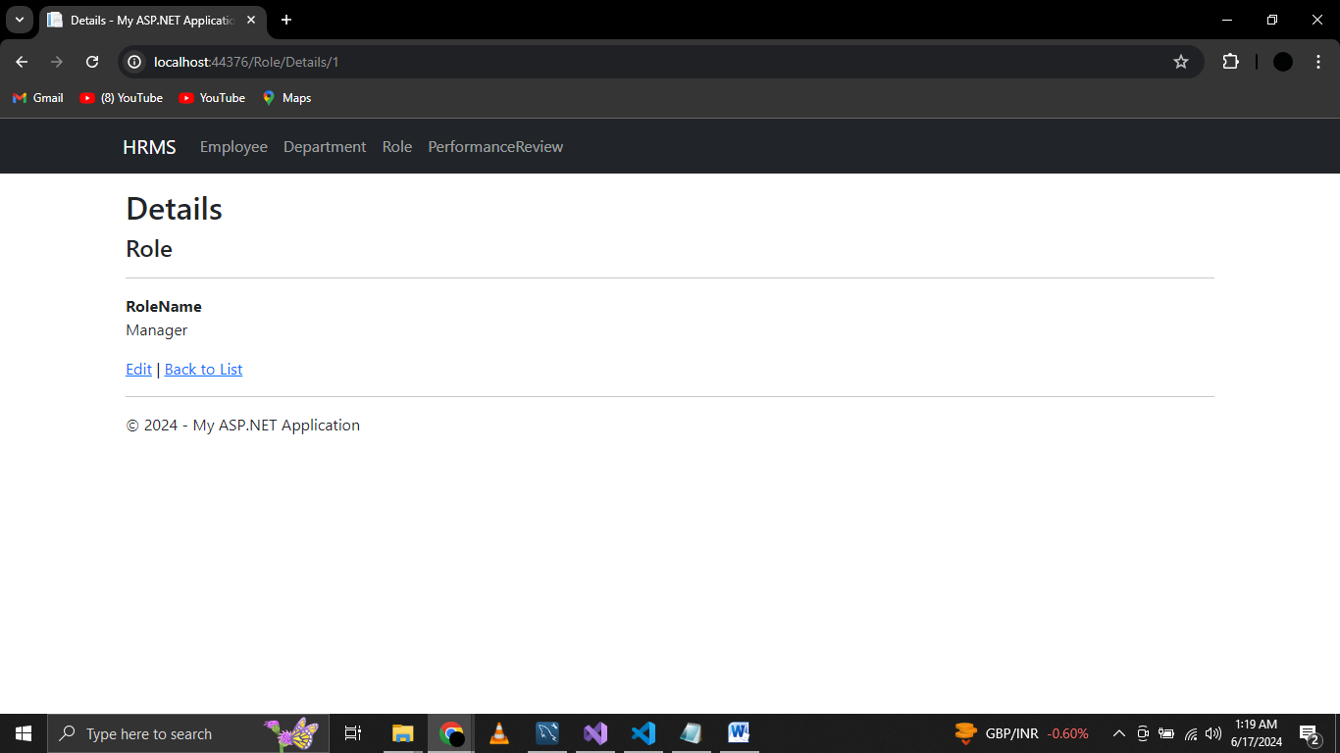

**Delete Role**

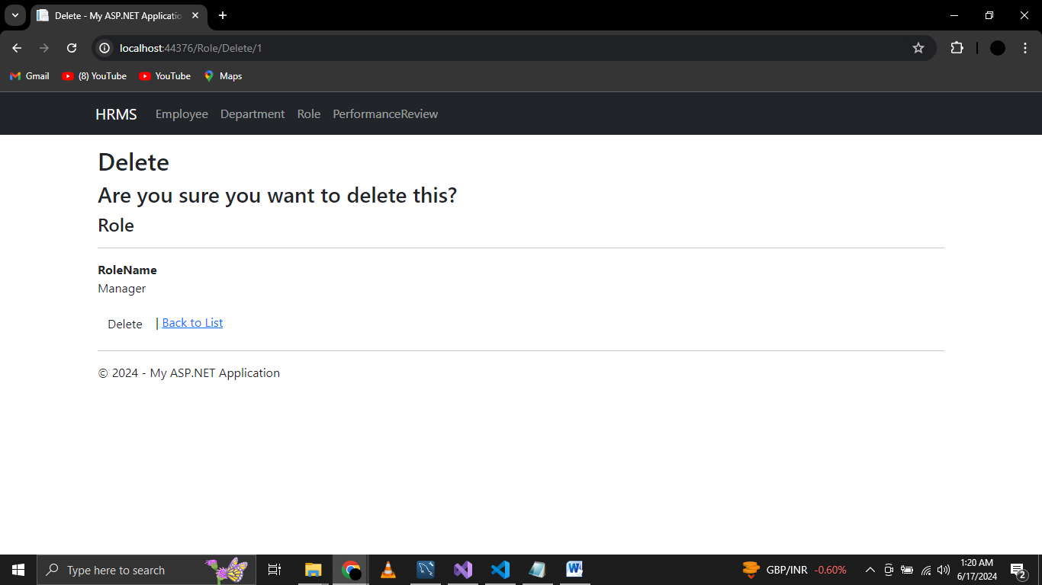

**Conduct and record performance reviews.**

**Performance Reviews**

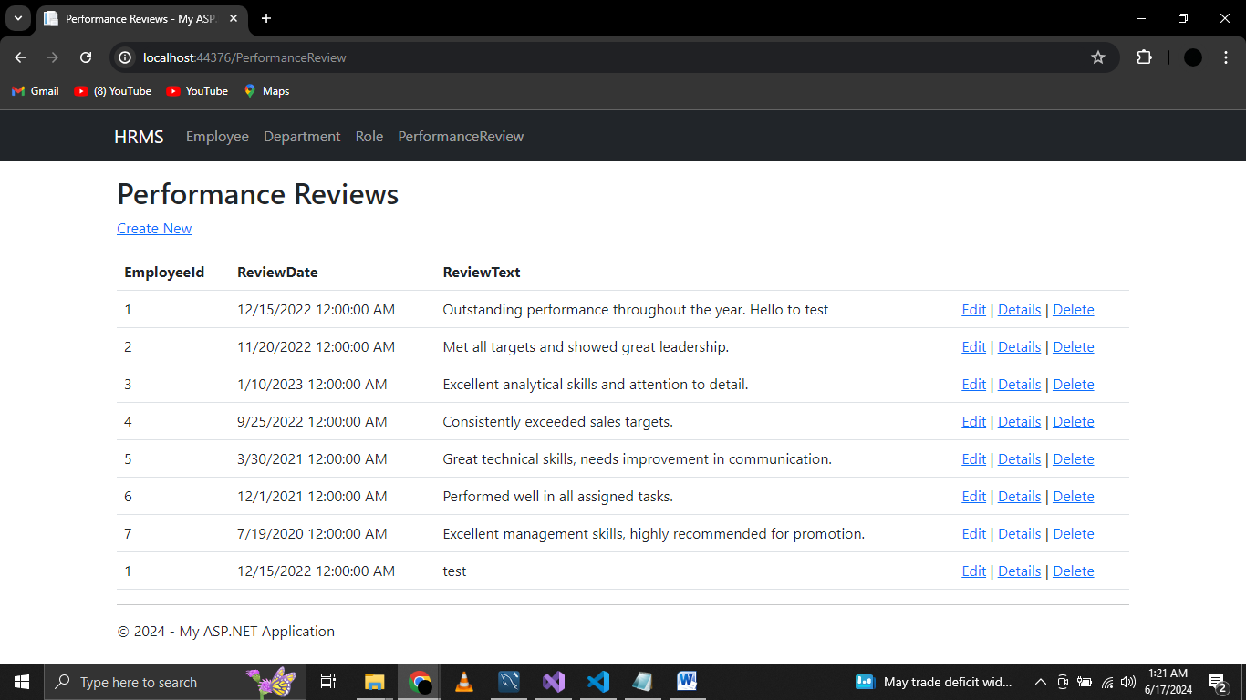

**Create Performance Review**

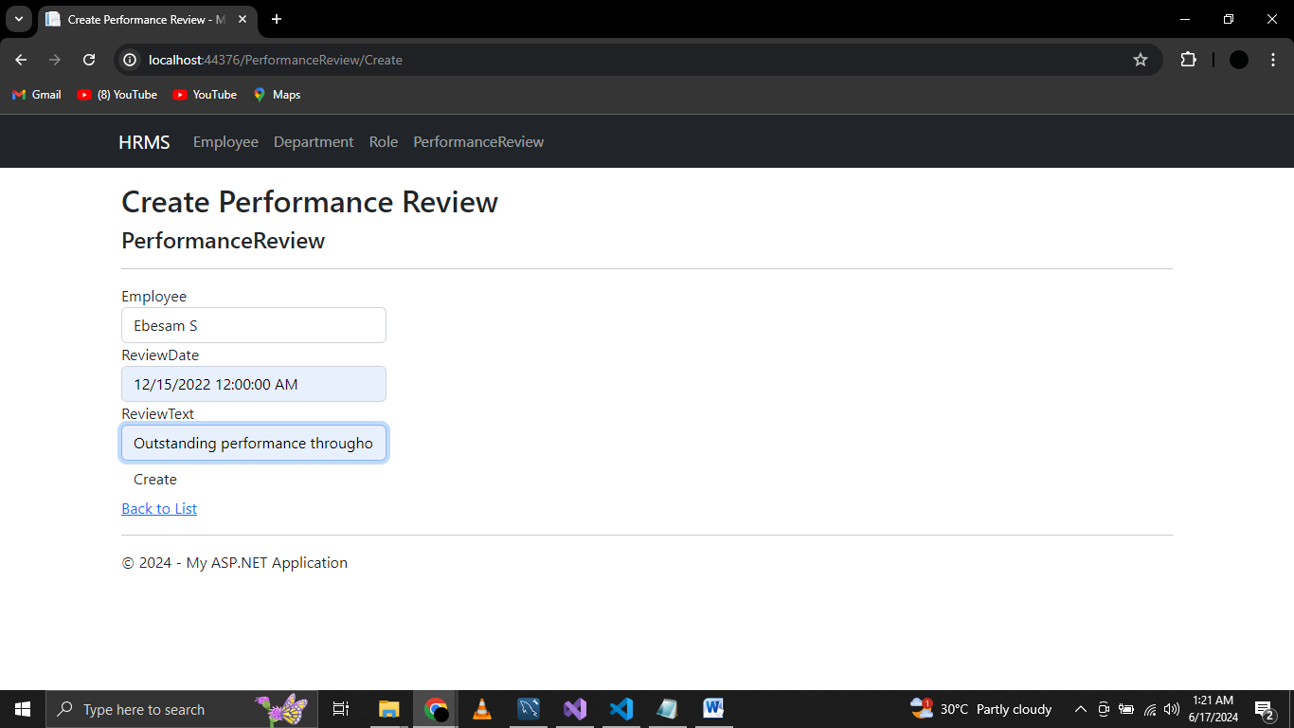

**Edit Performance Review**

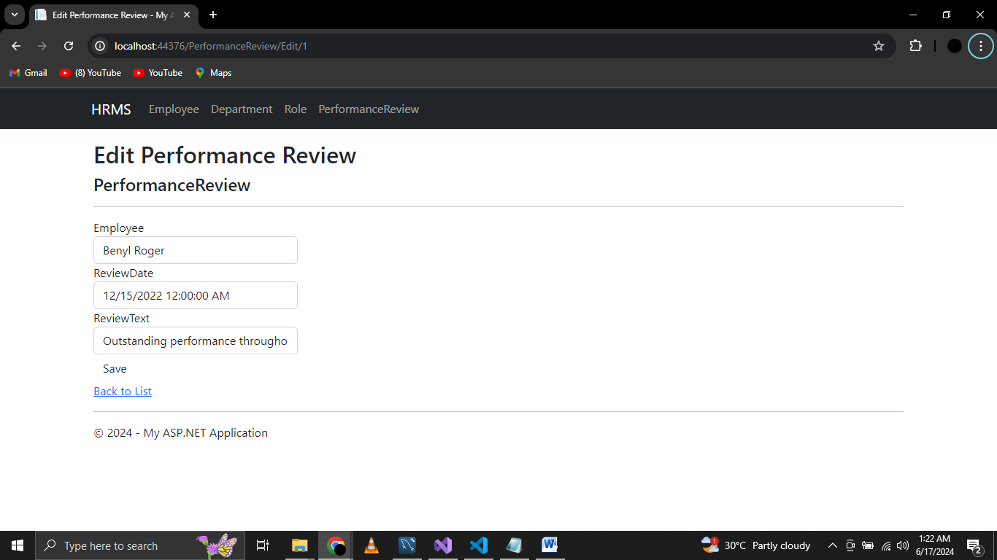

**Performance Review Details**

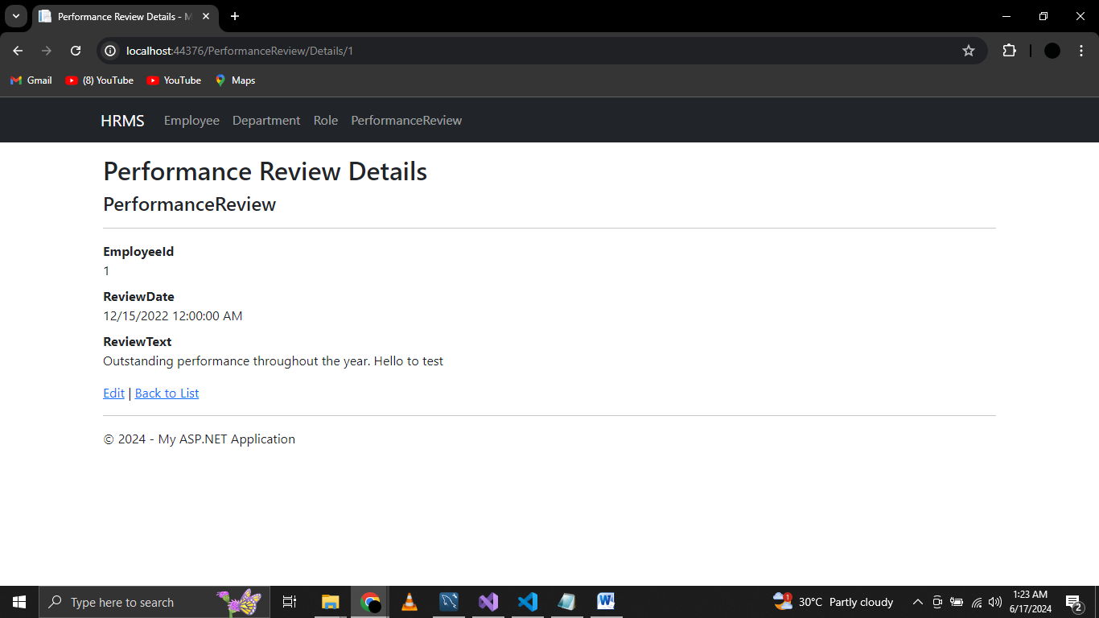

**Delete Performance Review**

